

**DevOps Tools**

Table of Contents

1

Table of Contents 2

1 Lab Details: 3

2 DevOps Tools: Guided Exercises 3

2.1.1 GIT – Problem Statement 3

Guided Exercise 1: 4

Guided Exercise 2: 6

Guided Exercise 3: 8

Guided Exercise 4: 9

# Lab Details:

You will be provided with the below DevOps Lab for practicing the guided exercise in this document.

1. Enroll for DevOps Tools - Practice Lab to practice these guided exercises.

# DevOps Tools: Guided Exercises

### GIT – Problem Statement

A leading hospital in India is working on their expansion plans and also planning to rebuild their existing website as an enterprise application on DevOps environment integrating with additional apps for various utilities. The hospital is having huge customers all over India and they are planning to provide apps that allows the users to check their wellness.

The entire application is planned to develop in DevOps environment which enables continuous integration and delivery. There are many developers working on it and the daily builds are updated to the Git repository.

**Scope:**

You have been assigned the task of managing the builds on the Git Repository for continuous integration of the project along with fellow developers.

Given the project build, you need to perform the following main tasks.

* Create a local repository for staging and committing files.
* Maintain the log of commits performed.
* Merge the commits locally before performing sync with the remote repository.
* Push your local repository update to GIT remote repository.

**Steps:**

1. Install, test and Configure GIT.

2. Initialize GIT local repository.

3. Create files in the Working directory (Local Repository).

4. Add files to staging area in the Repository.

5. Commit files to the repository.

6. Get information about the commit made to the repository.

7. Implement the command to add the data to remote repository.

8. Push data to remote repository.

Guided Exercise 1:Installing GIT on the system

**Estimated Completion Time:** 10 Minutes

**Objective:** To install and configure GIT on the system

**Steps to follow:**

**Step 1:**Download GIT and Set up GIT Environment

1. Copy the given BMICalculator.zip on your system, extract the zip file to any location and open the BMICalculator folder and right click and select GIT Bash. You will see the screen as provided in Fig 1.1 and 1.2.

**Source Code Attachment**



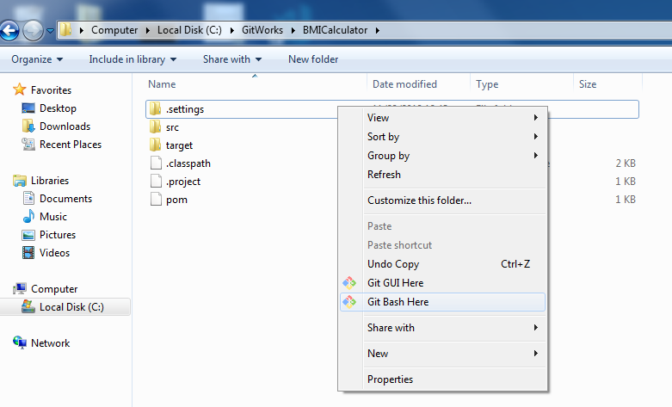

[ Fig 1.1]

**Step 2:** Test the environment.

**Solution:**

**Command: git --version**

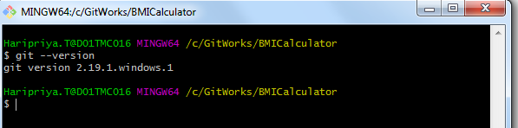

[Fig 1.2]

**Step 3:** Initializing GIT local repository and working with files in GIT environment

A. Check the current path:

**Solution:**

**Commands:**

* **pwd**
* **git init**



[Fig 1.3]

**Step 4:** Setting configuration

Set values for user name and email so that GIT can use this information to Identify

Users in the repository.

**Solution:**

**Commands:**

**git config -- all** (show all details of configuration)

**git config user.name** “your-name”

**git config user.email** “your-email”

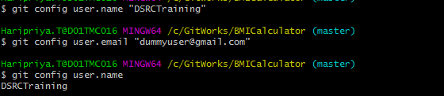

[Fig 1.4]

Guided Exercise 2: Working with files in GIT Environment

**Estimated Completion Time:** 20 Minutes

**Objective:** To add files from working area to staging area and commit these files to the Repository.

**Steps to follow:**

**Step 1:** Adding file’s from working directory to the Local Repository

Add Command To:

1. Navigate to the location where project is extracted .List the contents of the directory.

**Solution:**

**Command: ls –la**

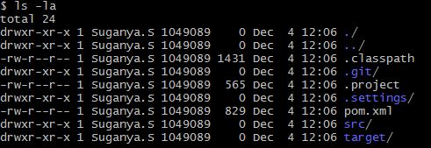

[Fig 2.1]

1. Get the status of the files

**Solution**

**Command: git status**

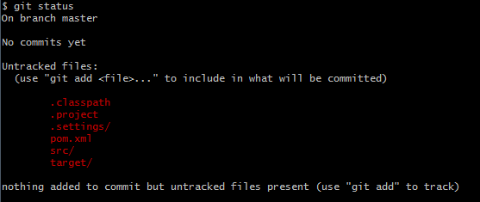

[Fig 2.2]

C. To add the java source files to the staging area, change to the folder where java files are existing and verify the current location. Refer Figure 2.3 and 2.4

**Solution:**

**Commands:**

**Cd <<Folder Location>>**

**pwd**



[Fig 2.3]



[Fig 2.4]

1. Verify the current status of source files.

**Solution:**

**Command: git status**

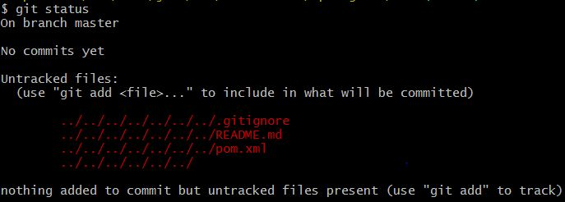

[Fig 2.5]

E. Add all files from src\main\java\com\mdhasan \bmicalculator folder to staging area (index area of GIT) like shown in the Fig 2.6.

**Solution:**

**Command: git add .**

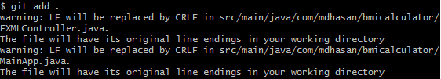

[Fig 2.6]

F: Verify the status .Refer Figure 2.7

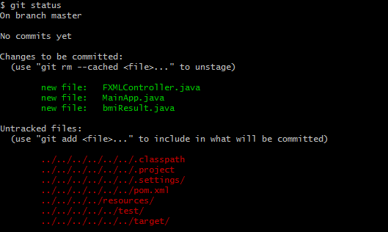

[Fig 2.7]

Guided Exercise 3:Viewing Repository History

**Estimated Completion Time:** 10 Minutes

**Objective:** To View commit History from the Repository

Steps to follow:

**Step 1:** The changes made to the source files are committed to the staging are by using the

**git commit –m “message”** command. Refer Figure 3.1

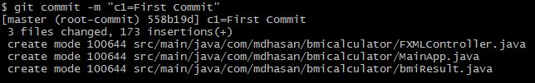

[Fig 3.1]

**Step 2:** Use the **git log** command to view all the commits made to the staging area.

Refer Figure 3.2.

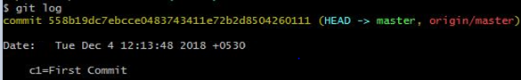

[Fig 3.2]

**Step 3:** Use **git log --oneline** command to view the commit information on each commit in a single line from the staging area as shown in Figure 3.3.

C:\Users\haripriya.t\Pictures\git23.JPG

[Fig 3.3]

**Step 4:** View the file information added to specific commit using commit 'SHA1 - hash value

File list from eda0bb2 (On your console the value may be different). Select any commit SHA1 hash value. Result shown in the Fig 3.4

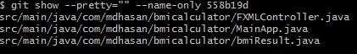

[Fig 3.4]

**Step 5:** Verify the status.

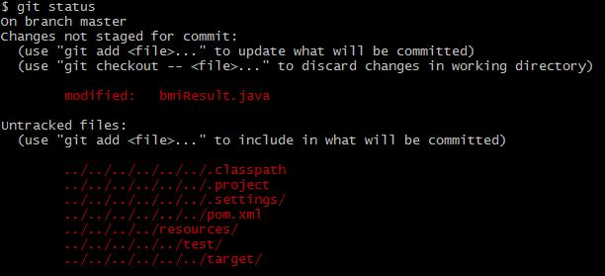

[Fig 3.5]

Guided Exercise 4:Adding Data to remote Repository

**Estimated Completion Time:** 5 Minutes

**Objective:** Synchronizing data with remote repository

Steps to follow:

**Step 1:**

* Log into GitLab with your Cognizant credentials to configure your repository <https://code.cognizant.com>
* Create a project named **cicd project** 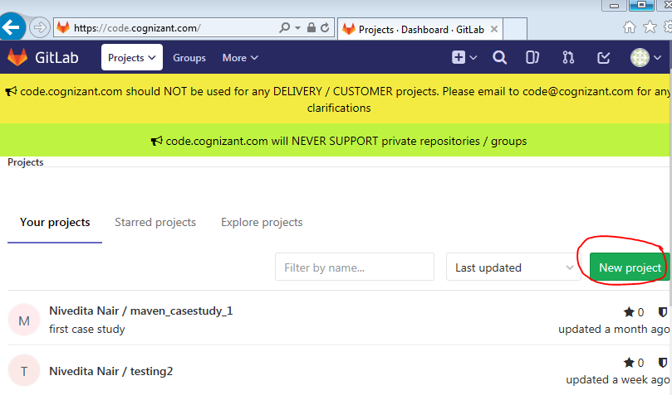

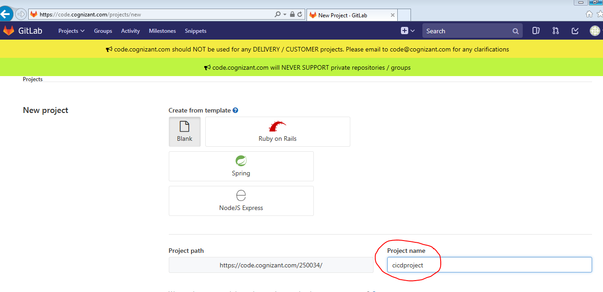

[Fig 1.5]

**Step 2:** Copy the GitLab project URL.  
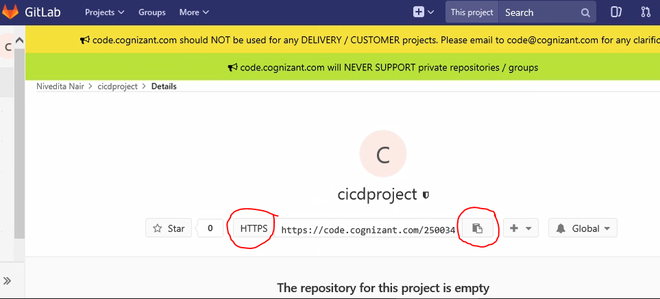

<https://github.com/DSRCTraining/BMI.git> (Sample URL)

**Step 3:** Copy the existing Git Repository to a local file system.

Clone the repo in a new directory, at another location. Refer Fig 4.4

**Solution:**

**Command; git clone <<repo Name>>**

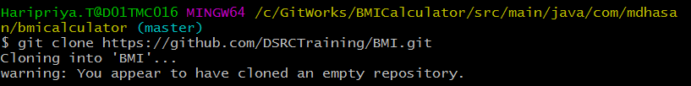[Fig 4.4]

**Git remote add origin** [**https://github.com/DSRCTraining/BMI.git**](https://github.com/SuganyaSrithar/BMI.git) to locate the target remote repository. Refer Figure 4.5

[Fig 4.5]

Hint: use push command push data to remote repository (use –u option with push)

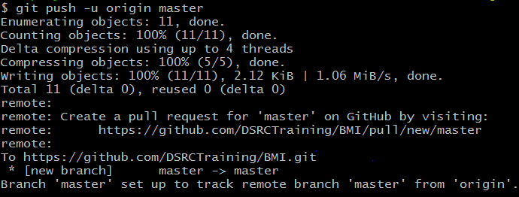

[Fig 4.6]

**Summary:**

You have learnt to configure GIT for DevOps Environment